Vamos Habilitar ele

ClienteRepository

**<?php***/**  
 * Created by PhpStorm.  
 * User: rafael.franco  
 * Date: 18/03/2016  
 * Time: 15:33  
 */***namespace** CodeProject\Repositories;  
  
  
**use** CodeProject\Entities\Client;  
**use** CodeProject\Presenters\ClientPresenter;  
**use** Prettus\Repository\Eloquent\BaseRepository;  
  
**class** ClientRepositoryEloquent **extends** BaseRepository **implements** ClientRepository  
{  
  
 **protected $fieldSearchable** = [  
 **'name'**,  
 **'email'** ];  
  
  
 **public function** model()  
 {  
 **return** Client::***class***;  
 }  
  
 **public function** presenter()  
 {  
 **return** ClientPresenter::***class***;  
 }  
  
 **public function** boot()  
 {  
 $this->pushCriteria(app(**'Prettus\Repository\Criteria\RequestCriteria'**));  
 }  
  
}

Buscar Igual

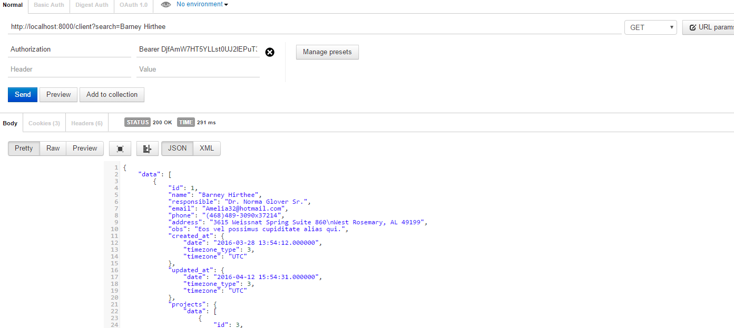

Where

http://localhost:8000/client?search=Barney Hirthee

Dando o Like

<http://localhost:8000/client?search=barne&searchFields=name:like>

Buscando o Email com Like

<http://localhost:8000/client?search=Amelia32&searchFields=name:like;email:like>

Adicionando o Filtro

<https://github.com/andersao/l5-repository#create-a-criteria>

Documentação